分体键盘ZMK STUDIO改键说明

Instructions for Changing Keymap via ZMK Studio on Split Keyboard

一、刷固件Flash the firmware

2024年12月25日之后购买的已经刷好了支持ZMK STUDIO的固件，无需重新刷机；12月25日之前购买的需要刷入新的支持ZMK STUDIO的固件。

If you purchased after December 25, 2024，the keyboards have already flashed the firmware that supports ZMK STUDIO, you do not need to re-flash it; purchased before December 25，you need to flash the new firmware to support ZMK STUDIO.

1. 刷机步骤Flashing steps

1.1 固件在zmk studio/firmware文件夹下与键盘名称对应的文件夹内。

The firmware is in the folder corresponding to the keyboard name in the zmk studio/firmware folder.

1.2 键盘通过USB A to C 或者C to C数据线连接电脑。

Connect the keyboard to the computer via a USB A to C or C to C cable.

1.3 快速双击键盘reset按钮（reset按钮通常是一个按压的微动开关，电源开关是滑动开关，二者形状不同，注意区分。按钮的位置通常在键盘的侧面或底部），正确双击后电脑上会出现一个名为nicenano的虚拟U盘，如果没出现，可能是：

Quickly double-click the keyboard reset button (the reset button is usually a micro switch that is pressed, and the power switch is a slide switch, the two are different shapes, pay attention to the difference. The position of the buttons are usually on the side or bottom of the keyboard), after double-clicking correctly, a virtual USB flash drive called nicenano will appear on the computer, if it doesn't appear, it may be:

a.双击速度过慢，多尝试几次；

The double-click speed is too slow, try a few more times;

b.使用的USB线或插的电脑USB接口问题，换根线或者换个USB接口尝试，特别是使用某些C to C数据线时，线的方向不对也会导致不出现U盘。还有可能是一些线材只有充电能力，没有数据传输功能。

Maybe the USB cable or the USB interface of the computer you used are not matching, try to change the cable or change the USB interface, especially when using some C to C cables, the wrong direction of the cable will also cause the USB flash drive to not appear. It is also possible that some cables only have the ability to charge and have no data transfer function.

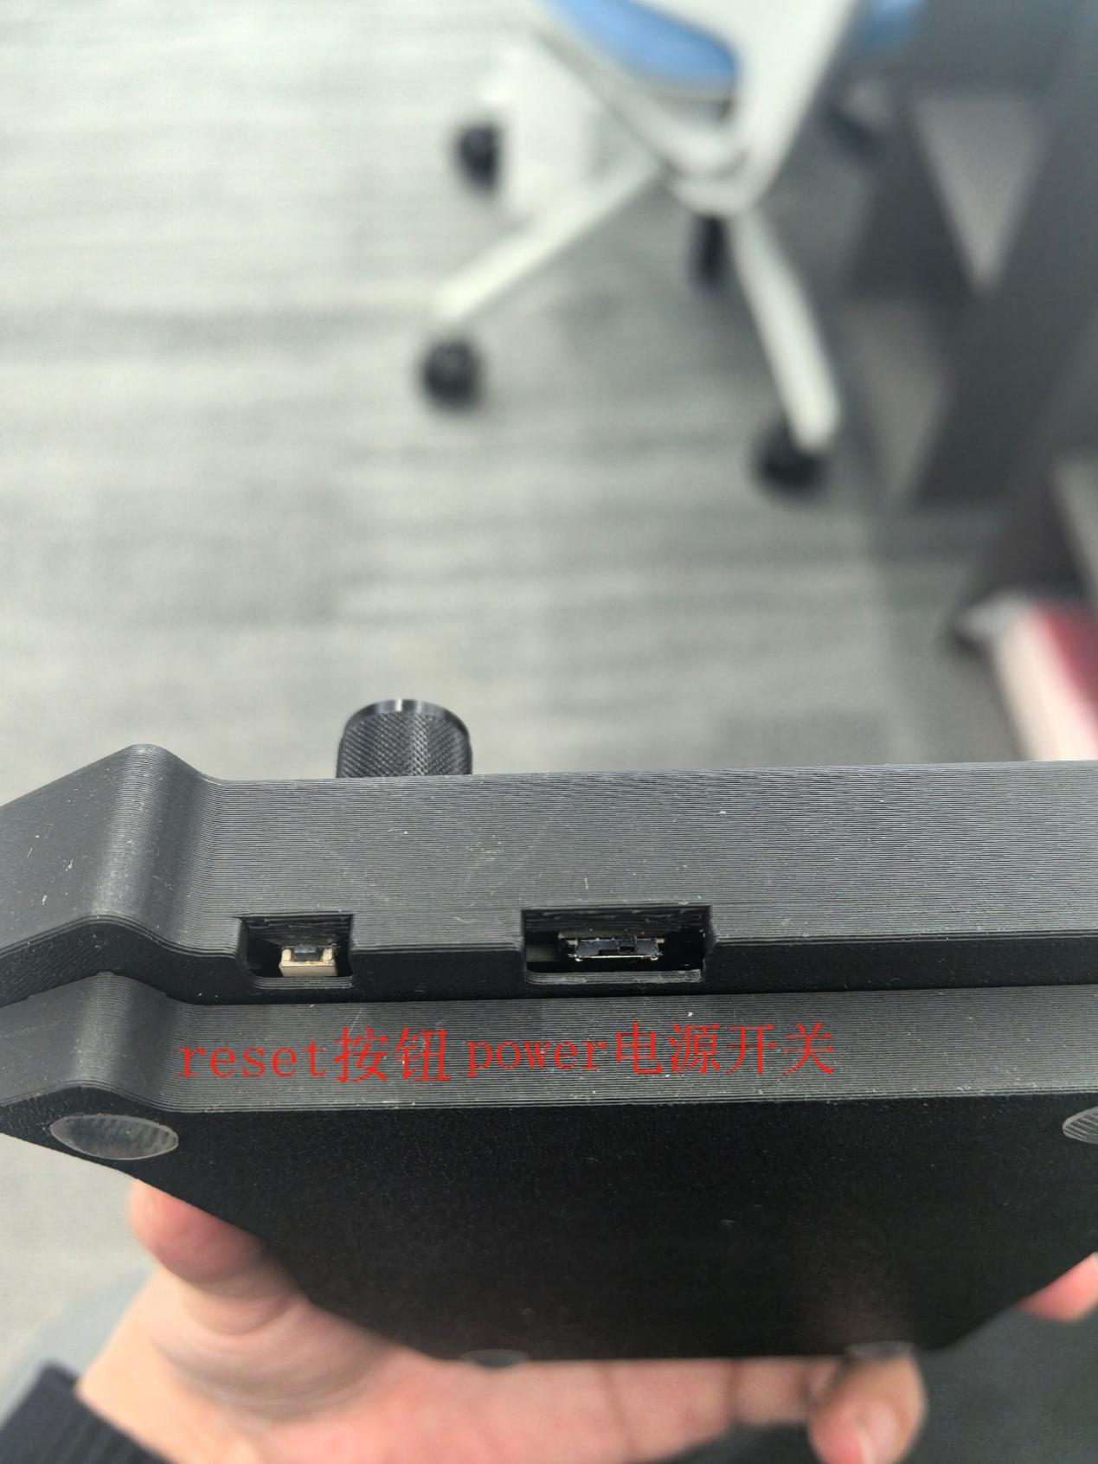

1.4先把文件名包含settings_reset的uf2文件拷贝到虚拟U盘，拷贝完成虚拟U盘自动弹出（Mac系统可能会报错，不用管，实际已经拷贝成功），然后再次双击reset按钮，把对应的uf2文件拷贝到虚拟U盘（左手文件名包含**left**，右手文件名包含**right**）。再次强调一下，需要先给左手键盘和右手键盘分别刷入setting reset固件。每次只能放入一个固件，不可以放入多个固件。放入固件的过程就是刷固件的过程，固件会被转译成键盘可执行程序，而不是真的存储在键盘里。都刷完setting reset之后再给左手键盘和右手键盘分别刷入自己对应的固件。

First copy the uf2 file which name including settings_reset to the virtual USB disk, and the virtual USB flash drive will automatically pop up after the copy is completed (the Mac system may report an error, don't care, the actual copy has been successful), and then double-click the reset button again to copy the corresponding uf2 file to the virtual USB flash drive (the left-handed file name including left, and the right-hand file name including right). Again, you need to flash the setting reset firmware to the left-handed keyboard and the right-handed keyboard respectively. Only one firmware can be inserted at a time, and multiple firmware cannot be inserted. The process of putting in the firmware is the process of flashing the firmware, and the firmware is translated into a keyboard executable instead of actually being stored in the keyboard. After you have finished setting reset, flash the firmware corresponding to the left-handed keyboard and the right-hand keyboard respectively.

1.5 如果键盘左手屏幕未显示无线图标而是显示齿轮图标，或PC端的连接状态频繁在“已连接”-“已配对”切换，则需要重新配对。在电脑中删除已配对的键盘，键盘端键入bt-clear-all这个键码清空键盘上的连接记录，之后重连即可。

If the left-hand screen of the keyboard does not display the wireless icon but displays the gear icon, or the connection status of the PC frequently switches between "Connected" and "Paired", you need to pair again. Delete the paired keyboard on the computer, type the bt-clear-all key on the keyboard to erase the connection record on the keyboard, and then reconnect it.

桌子上放了不同类型的电子产品

1.6 如果左手能输入，右手显示X或者WIFI图标但输入没反应，请尝试：

If you can input with your left hand, and the X or WIFI icon is displayed on your right hand but the input does not respond, please try:

a.右手键盘单机reset按钮；

Stand-alone reset button on the right-hand keyboard;

b.重刷固件。

Reflash the firmware.

原因是左右手键盘配对失败，大概率是刷错了固件。所以请重复之前介绍的步骤。给左右手键盘分别刷入setting-reset固件，此时键盘内的所有配对信息会被清空，相当于键盘倍格式化了。之后再给键盘刷入自己对应的固件。左手键盘刷left，右手刷right。

The reason is that the pairing of the left and right hand keyboards failed, and it is likely that the wrong firmware was flashed. So repeat the steps described earlier. Flash the setting-reset firmware to the left and right hand keyboards respectively, and all pairing information in the keyboard will be cleared, which is equivalent to the keyboard multiple formatting. After that, flash the keyboard into its own firmware. Swipe left on the left keyboard and right on the right hand.

1.8 如果左手一直连接不上电脑，请尝试：

If your left hand is not connected to the computer, try to:

a.电脑上删除键盘连接；

Remove the keyboard connection from the computer;

b.键盘上键入bt-clear-all清空键盘连接记录。

Type bt-clear-all on the keyboard to empty the keylink record.

补充介绍，另外的文档里有介绍。键盘有五个蓝牙通道。每个都可以连接一台电脑，这就意味着如果通道1连接了电脑，您切到了通道2键码是不会发送给通道1的。所以请仔细阅读另外一个说明文档，并查看按键功能分布图，记住bt-sel-0、bt-sel-1等通道切换按键。如果弄错了就bt-clear-all 全部清空，电脑端删除连接记录重连。

Additional introductions are provided in separate documents. The keyboard has five Bluetooth channels. Each can be connected to a computer, which means that if channel 1 is connected to a computer, the keycode you switch to channel 2 will not be sent to channel 1. So please read the other document carefully, and look at the key function distribution chart, remember the bt-sel-0, bt-sel-1 and other channel switching buttons. If you make a mistake, bt-clear-all will be cleared, and the connection record will be deleted and reconnected on the computer.

二、通过ZMK STUDIO实时改键

Change the key in real time through ZMK STUDIO

ZMK STUDIO可以实时修改键盘键位，修改后自动生效，无需重刷固件。

ZMK STUDIO can modify keyboard keys in real time, and the modification will take effect automatically and no need to reflash the firmware.

**注意：改键后，有概率自动保存失败，导致关闭软件后键位还原。因此关闭软件之前，请点击右上角保存。**

**Note: After changing the keymap, there is a probability that the auto-save will fail, resulting in the key restoration after closing the software. So before closing the software, click on the top right corner to save.**

2.1 改键工具Rekey Tool

2.1.1 网页端（使用Chrome/Edge/Firefox浏览器）Web (Chrome/Edge/Firefox)

https://zmk.studio/

部分操作系统下网页端无法使用蓝牙连接键盘的方式改键，只能使用有线连接。

Under some operating systems, the web terminal cannot use Bluetooth to connect to the keyboard to change the key, and can only use a wired connection.

2.1.2 PC端**（以管理员身份运行EXE程序）**PC **(Run the EXE program as administrator)**

当前最新版本的安装包已经放在zmk studio 0.2.4文件夹里了，可根据需要选择适合自己电脑系统的安装包安装。也可以到<https://github.com/zmkfirmware/zmk-studio/releases> 下载，国内用户连接GITHUB不稳定，部分时段需要科学上网。

The latest version of the installation package has been placed in the zmk studio 0.2.4 folder, you can choose the installation package suitable for your computer system according to your needs. You can also download it from <https://github.com/zmkfirmware/zmk-studio/releases> , and some hours users in China need to use VPN to connect github.

2.2 改键步骤Rekey Steps

2.2.1 通过蓝牙或有线方式连接电脑Connect to the computer via Bluetooth or wired

改键仅需左手连接电脑，右手不需要连接。

To change the key, you only need to connect to the computer with your left hand, and you don't need to connect with your right hand.

MAC端使用有线连接改键时，PC端必须选择第三个有线端口（同时连接了蓝牙时，选第四个，第一个是蓝牙端口），网页端要选择除蓝牙端口外的第二个端口，如果选错了，必须关闭软件，重新连接，否则端口会被占用。

When MAC uses wired connection to change the key, the PC must select the third wired port (when Bluetooth is connected at the same time, select the fourth, the first is the Bluetooth port), and the web side must choose the second port in addition to the Bluetooth port, if you choose the wrong one, you must close the software and reconnect, otherwise the port will be occupied.

Win系统选择第二个USB端口，如打开失败请关闭软件或者网页，然后重新打开并更换其他端口尝试。

If the system fails to open the second USB port, please close the software or web page, and then reopen and replace the other port.

下图为mac版本studio的选择页面。

The following figure shows the selection page for the Mac version of Studio.

2.2.2 改键界面说明Description of the key change interface

2.2.2.1 behavior行为

ZMK STUDIO目前仅支持修改基础的behavior，在固件里写好的自定义behavior（如：旋钮，模拟鼠标等）在Studio中可以调用，如需修改自定义behavior参数仍需使用重刷固件的方式，但使用ZMK STUDIO改键后，固件中已经设置好的旋钮动作也不会被清除。

ZMK STUDIO currently only supports modifying the basic behavior, and the custom behavior written in the firmware (such as: encoder, emulates mouse, etc.) can be called in Studio, if you need to modify the custom behavior parameters, you still need to use the method of reflashing the firmware, but after using ZMK STUDIO to change the key, the knob action that has been set in the firmware will not be cleared.

图形用户界面

常用behavior说明如下：

The following table describes common behaviors:

|  |  |  |
| --- | --- | --- |
| Behavior | Description |  |
| Key Press | Send keycodes to the connected host when a key is pressed | 普通按键 |
| Mod Tap | Sends a different key press depending on whether a key is held or tapped | 长按输出一个Key Pres值，短按输出另一个Key Press值 |
| Transparent | Passes the key press down to the next active layer in the stack for processing | 与上一层的键值相同 |
| None | Swallows and stops the key press, no keycode will be sent nor will the key press be passed down to the next active layer in the stack | 空键值 |
| Momentary Layer | Enables a layer while a key is pressed | 按下切换到指定层，松开恢复默认层 |
| Layer-tap | Enables a layer when a key is held, and outputs a key press when the key is only tapped for a short time | 长按实现Momentary Layer功能，短按实现Key Press功能 |
| Mouse Button Press | Emulates pressing mouse buttons | 模拟鼠标按键 |
| Mouse Move | Emulates mouse movement | 模拟鼠标移动 |
| Bluetooth | Completes a bluetooth action given on press, for example switching between devices | 蓝牙相关 |
| RGB Underglow | Controls the RGB underglow, usually placed underneath the keyboard | RGB底灯相关 |
| ZMK Studio Unlock | Unlocks the device so that ZMK Studio UI can make changes | ZMK Studio解锁 |

更多behavior可自行前往<https://zmk.dev/docs/keymaps/behaviors> 查阅。

More behaviors can be found on <https://zmk.dev/docs/keymaps/behaviors> page.

2.2.2.2 Keycode键码

在Behavior菜单选择Key Press后，在Key菜单选择需要的keycode。

After selecting Key Press in Behavior menu, select the keycode you need in the Key menu.

右侧的修饰键选项勾选时，表示输出选定的keycode+修饰键的组合，修饰键可多选。如：L Ctrl + A ，L Ctrl +L Alt + Delete

When the modifier key option on the right is checked, the combination of selected keycode + modifier key is output, and the modifier key can be selected in multiple ways. For example: L Ctrl + A, L Ctrl + L Alt + Delete

图形用户界面

改键时可参考zmk studio keycode.xlsx 文件，根据描述找到所需的keycode，复制粘贴到ZMK STUDIO界面的Key菜单，会自动匹配。

When changing the key, you can refer to the zmk studio keycode.xlsx file, find the required keycode according to the description, copy and paste it into the key menu on the ZMK STUDIO interface, and it will be automatically matched.